1960's Civil Rights Movement
Black Americans struggled for racial equality in the 1950's and 1960's. Earlier in the century, many states enacted "Jim Crow" laws. Jim Crow laws were named for a song sung by a white minstrel character of the mid 1800's who imitated popular Negro crooning and dancing.

Jim Crow Laws
Jim Crow laws were passed by Southern states that created a racial caste system in the American South. By 1914 laws effectively created two separate societies; one black and one white. Blacks and whites could not ride together in the same rail car, sit in the same waiting room, sit in the same theatre, attend the same school or eat in the same restaurant. Moreover, black Americans were denied access to beaches, swimming pools, parks, picnic areas and many hospitals.
In 1954, the United States Supreme Court struck down segregation in the nation's public schools. Rosa Park's refusal to give up her bus seat to a white man in 1955 sparked intense protests by blacks and concerned whites. In 1956, a boycott desegregated buses in Montgomery, Alabama. In 1960, in Greensboro, North Carolina, black college students seated themselves in a whites-only restaurant lunch counter. This sit-in resulted in many other similar protests throughout the South. The Civil Rights Movement began in earnest as blacks and whites joined to protest unfair laws and to promote equal rights for all blacks.

1960-1970 Civil Rights Movement
Throughout the 1960's, bus riding Freedom Riders, marchers, boycotters and other protesters continued their crusade for freedom and were met with fierce white and establishment resistance. Riots, bombings, beatings and shootings were common as growing thousands of civil rights protesters marched throughout the South and in many cases the North as well. Ku Klux Klan members and other whites who believed in white supremacy spread terror all through the South.

Martin Luther King, Jr.
On August 28, 1963, over 250,000 people, including thousands of whites, gathered at the Lincoln Memorial in Washington D.C. The emerging leader of the Civil Rights Movement, Martin Luther King, Jr., gave his famous "I have a dream" speech. Continued protests, boycotts and marches gradually convinced the American populace to seriously consider major changes to the way blacks were treated in America.
The assassination of Martin Luther King, Jr. on April 3, 1968 and the ensuing race riots and protests shocked America and galvanized support for the Civil Rights Movement.

The Montgomery Bus Boycott
The Montgomery Bus Boycott, a seminal event in the U.S. civil rights movement, was a political and social protest campaign against the policy of racial segregation on the public transit system of Montgomery, Alabama. The campaign lasted from December 1, 1955, when Rosa Parks, an African American woman, was arrested for refusing to surrender her seat to a white person, to December 20, 1956, when a federal ruling, Browder v. Gayle, took effect, and led to a United States Supreme Court decision that declared the Alabama and Montgomery laws requiring segregated buses to be unconstitutional. Many important figures in the civil rights movement took part in the boycott, including Reverend Martin Luther King, Jr. and Ralph Abernathy.
Barrack Hussain Obama
Barack Hussein Obama II ( August 4, 1961) is the 44th and current President of the United States, and the first African American to hold the office. Born in Honolulu, Hawaii, Obama is a graduate of Columbia University and Harvard Law School.

Black Educational Attainment by The Numbers
1.6 million
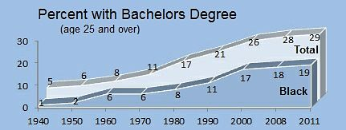
Among African Americans age 25 and older, the number who had an advanced degree in 2011 (e.g., master’s, Ph.D., M.D. or J.D.). Fifteen years earlier—in 1995—only 677,000 blacks had this level of education.
3.9 million
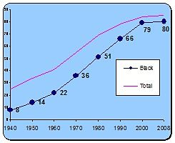 Number of black college students in 2011. This was an increase of roughly 2 million from 18 years earlier.

18.7%
Percentage of African Americans age 25 and older who had a bachelor’s degree or more in 2011. In many states, the rate was higher. Just over 22% of blacks this age in Massachusetts, for instance, had this level of education.
Crime

Percent Searched, Handcuffed, and Arrested
Even though the same percentage of Whites, Blacks, and Hispanics were stopped by police (9%), African Americans were:
- three times more likely to to be searched (person or vehicle) than Whites
- more than three times more likely to be handcuffed
- almost three times more likely to be arrested.
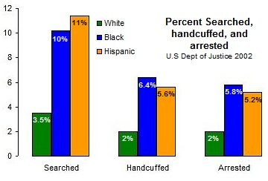
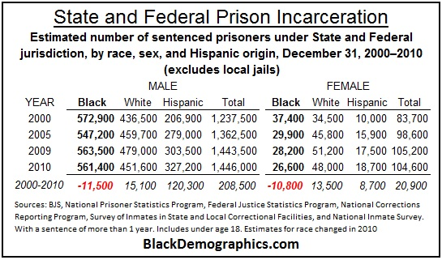

Theories of violence
Violence is part of our daily lives and always has been. Every day when we watch TV, listen to the radio or read the papers, we learn about acts of violence. There are three main theories why people use violence:
1. Violence is an instinct which we all have. Violence is necessary for survival. Some psychologists say that energy, will and courage are forms of violence. If violence is an instinct it will always be with us. The only thing we can do is to find harmless ways of acting out our violence, such as sport competitions.
2. Violence is something that we learn. We hear about violence, see it, experience it and imitate it. If violence is the result of a learning process, this means, that we can get rid of it if we want.
3. Another theory says that violence is the result of frustration. When we do not get what we want we become frustrated and this frustration leads to aggressive behaviour. Because people will always experience frustration, aggression will always exist. People, however, often learn not to hurt others but to take it out on things, e.g. to slam a door. Unfortunately some also pass on their frustration.
Gun Control
Ownership of most types of firearms is allowed by citizens except criminals and the mentally ill. In addition, the carrying of concealed weapons is explicitly allowed in most states (NY,NJ,CA,MA,RI,CT,HI,MD,DE are may issue) except for a small set of prohibitions like mental illness, convicted felon, etc. Regulation regarding the purchase process, type of firearms allowed, and purchase of ammunition varies from state to state.
The issue of firearms has, at times, taken a high-profile position in United States culture and politics.
Incidents of gun violence and self-defense also generate debate. In 2007 12,632 murders were committed using firearms and 613 persons were killed unintentionally.

Amendment II
A well regulated militia, being necessary to the security of a free state, the right of the people to keep and bear arms, shall not be infringed.
The Second Amendment was adopted on December 15, 1791, as part of the first ten amendments comprising the Bill of Rights.
Brady Law
Brady Law, in full Brady Handgun Violence Prevention Act, an element of Pres. Bill Clinton’s 1993 crime bill. It called for a five-day waiting period for the purchase of a handgun and, after 1998, a background check of any individual purchasing a firearm from a federally licensed dealer. Before the measure became a law, it was popularly known as the Brady bill, named for James Brady, the White House press secretary who was seriously injured in the 1981 assassination attempt against Pres. Ronald Reagan.
